**FRENCH GENDARMERIE CAPTURE KEY MEMBERS OF ARMENIAN MAFIA**

*18 January 2019*

*Press Release*

[Print](https://www.europol.europa.eu/print/newsroom/news/french-gendarmerie-capture-key-members-of-armenian-mafia)[PDF](https://www.europol.europa.eu/printpdf/newsroom/news/french-gendarmerie-capture-key-members-of-armenian-mafia)

* [E-mail](mailto:?subject=French%20Gendarmerie%20capture%20key%20members%20of%20Armenian%20mafia%20%7C%20Europol&body=https%3A%2F%2Fwww.europol.europa.eu%2Fnewsroom%2Fnews%2Ffrench-gendarmerie-capture-key-members-of-armenian-mafia)
* [Facebook](http://www.facebook.com/share.php?u=https%3A%2F%2Fwww.europol.europa.eu%2Fnewsroom%2Fnews%2Ffrench-gendarmerie-capture-key-members-of-armenian-mafia&t=French%20Gendarmerie%20capture%20key%20members%20of%20Armenian%20mafia%20%7C%20Europol)
* [Twitter](https://twitter.com/intent/tweet?url=https%3A%2F%2Fwww.europol.europa.eu%2Fnewsroom%2Fnews%2Ffrench-gendarmerie-capture-key-members-of-armenian-mafia&text=French%20Gendarmerie%20capture%20key%20members%20of%20Armenian%20mafia%20%7C%20Europol)
* [LinkedIn](http://www.linkedin.com/shareArticle?mini=true&url=https%3A%2F%2Fwww.europol.europa.eu%2Fnewsroom%2Fnews%2Ffrench-gendarmerie-capture-key-members-of-armenian-mafia&title=French%20Gendarmerie%20capture%20key%20members%20of%20Armenian%20mafia%20%7C%20Europol&ro=false&summary=&source=)

THIS NEWS/PRESS RELEASE IS ABOUT [MOBILE ORGANISED CRIME GROUPS](https://www.europol.europa.eu/crime-areas-and-trends/crime-areas/mobile-crime-areas-and-trends-groups)

[*View all crime areas*](https://www.europol.europa.eu/crime-areas-and-trends/crime-areas)

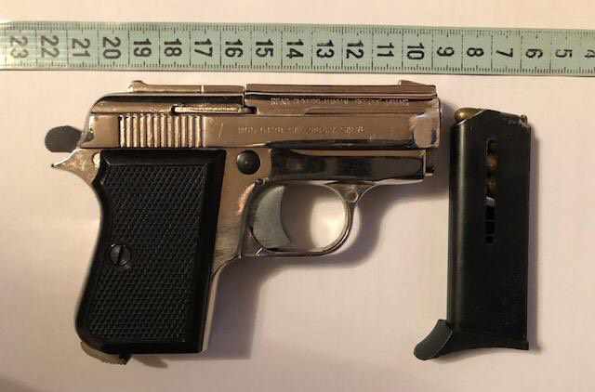On 14 January, some 200 officers from the Gendarmerie Nationale (French Gendarmerie) and Customs, with on-the-field support of Europol, targeted suspects across France believed to be part of an Eurasian mafia group composed mainly of Armenian individuals involved in large-scale poly-criminal activities, including cigarette smuggling, extortion and money laundering.

Over 27 house searches were carried out in Rennes, Gap, St. Etienne, Nancy, Strasbourg, Haguenau, Reims, Chalon-Sur-Saone, Paris, Nantes, Limoges and Brest. As a result, 21 suspects were arrested, including an individual believed to be a high-ranking member of this mafia group. Some €23 000 in cash were seized at the premises, alongside over 2 000 packs of cigarettes, 23 kg of raw tobacco and 6 weapons.

The sting follows a lengthy and complex investigation supported by the Spanish and the German authorities looking into the activities of this criminal network. The suspects used a special modus operandi were cars were used a mean of payment for further criminal actions (ie. the exchange of drugs or cigarettes against cars).

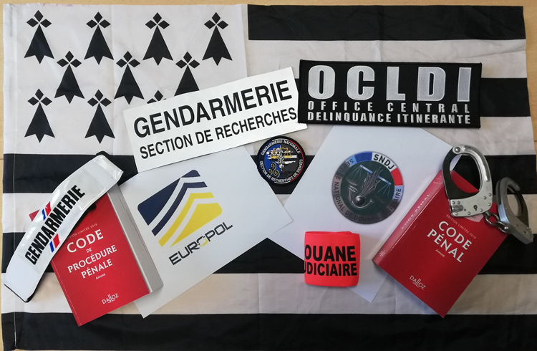Europol supported the investigation for the past year and a half by facilitating the exchange of information. On the action day, 2 Europol experts were deployed in Rennes to allow for real-time exchange of information and cross-checks of the data gathered in the course of the action against Europol’s databases.